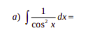

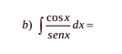

cot gx
ln|sen x| + c

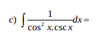

sec x .
sec x . tg x
sec x + C

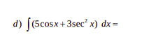

5. cos x + 3. sec² x
5 . sen x + 3 . tg x + C

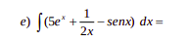

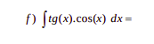

. cos x
sen x dx
- cos x + C

